In case of problem in downloading the attached file

You need to disable Popup blocker

Internet Explorer
With the release of Microsoft Windows XP Service Pack 2, pop-up blocking is integrated into Internet Explorer. By default, pop-up blocking is enabled.
Listed below is the location of the menu within Internet Explorer:
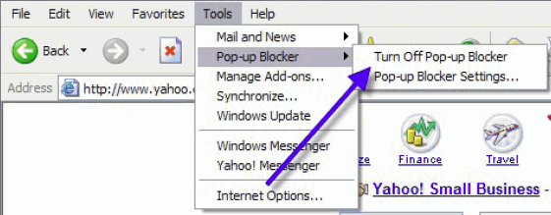
To disable pop-up blocking: click Tools, then Pop-up Blocker, then Turn Off Pop-up Blocker.
By Turning Off the Pop-up Blocker, the file would be opened and download easily.

